

**Database Systems 1**

**Library Management System(Loaning)**

**Supervised By:**

1. **Prof : Hanafy Ismail**
2. **T.A: Omar Khaled**
3. **T.A: Mohamed Ezzat**

**Submitted By:**

**1.Mahmoud Mohamed Samy Abdallah (G10)**

**2.Ziad Ahmed Mohamed El-dawy (G4)**

**3.Mahmoud Mohamed Abdallah abdel moaty (G10)**

**4.Mostafa Khaled Ibrahim Mohamed ElRayan (G10)**

**Table Of Contents:**

**1.Introduction**

**2.Functional View**

**3.ER Diagram ,Mapping**

**4.Database Relationships ,Tables with sample data**

**5.Input/Output Interface Design**

**a. Main Menu**

**b. Forms**

**c. Transactions**

**d. Queries**

**e. Reports**

**1.Introduction**

**First of all that’s a representation for our Library management system which allow students to loan and return books and search for books via signing in while the admin is responsible of adding any new students to the library , student can view his report which contains the username and password to memorize them to sign in ,admin can search books too and he can manage books and its’ categories he can add or remove students too and can view his report which contains the username and password to memorize them to sign in**

**2.Functional View**

**Maintain Basic Data**

1-book(ISBN(Pk) , Category , author , quantity , titles)

2-category(id(Pk) , title)

3-lib admin(id(PK),username , password)

4-lib user(student id(Pk),username , loan return)

5- loan book(id(Pk), ISBN , student id , loan return)

**Issue Query Subsystems**

1.Search Book by ISBN

2.Search Book by Title

3.Search Book By Author

4.Search Book By Category

5.Search Student By ID

**Perform Transactions**

Add,Delete,Update (all entities)

**Generate Reports**

**Managerial Reports**:

1. Total Books Budget
2. Total Loaned Books

**Generate Reports:**

1. Number of admins
2. Number of Books
3. Number of students

**3.ER Diagram ,Mapping**

**ER Diagram:**

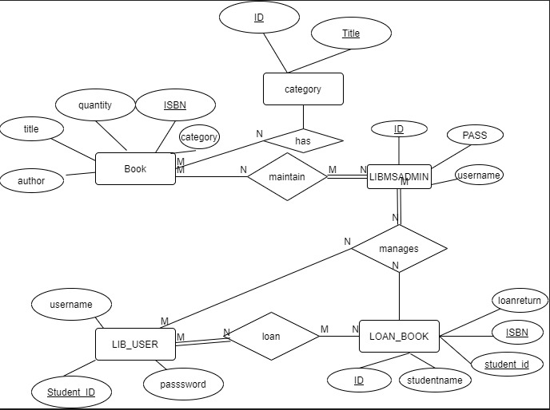

**Mapping:** 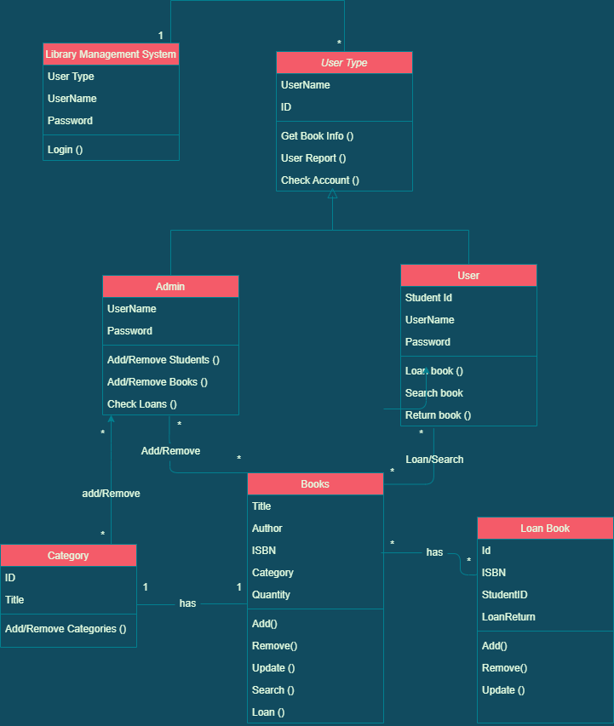

**4.Database Relationships ,Tables with sample data**

**Database Relationships:**

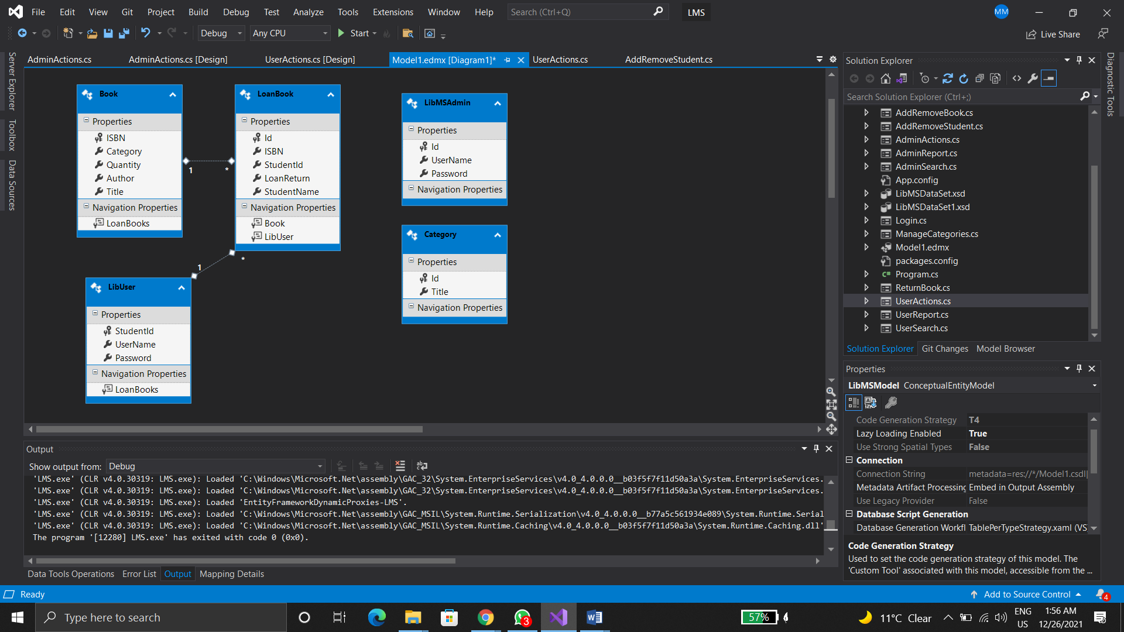

**Tables with sample data**

**Books:**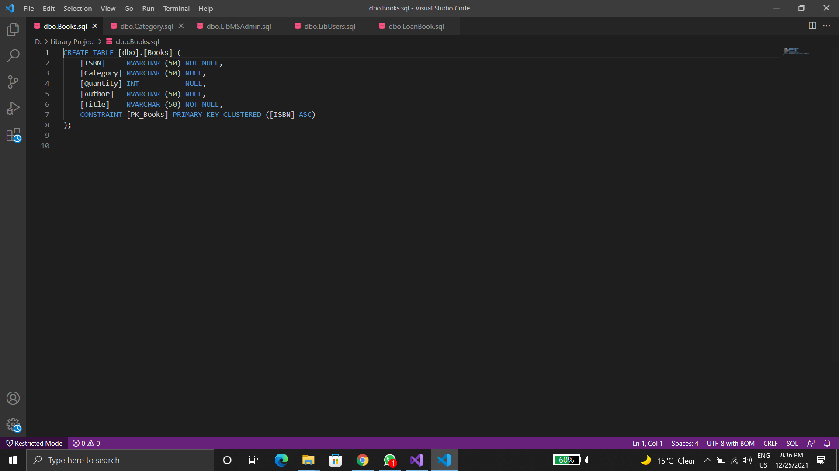

**Category:** 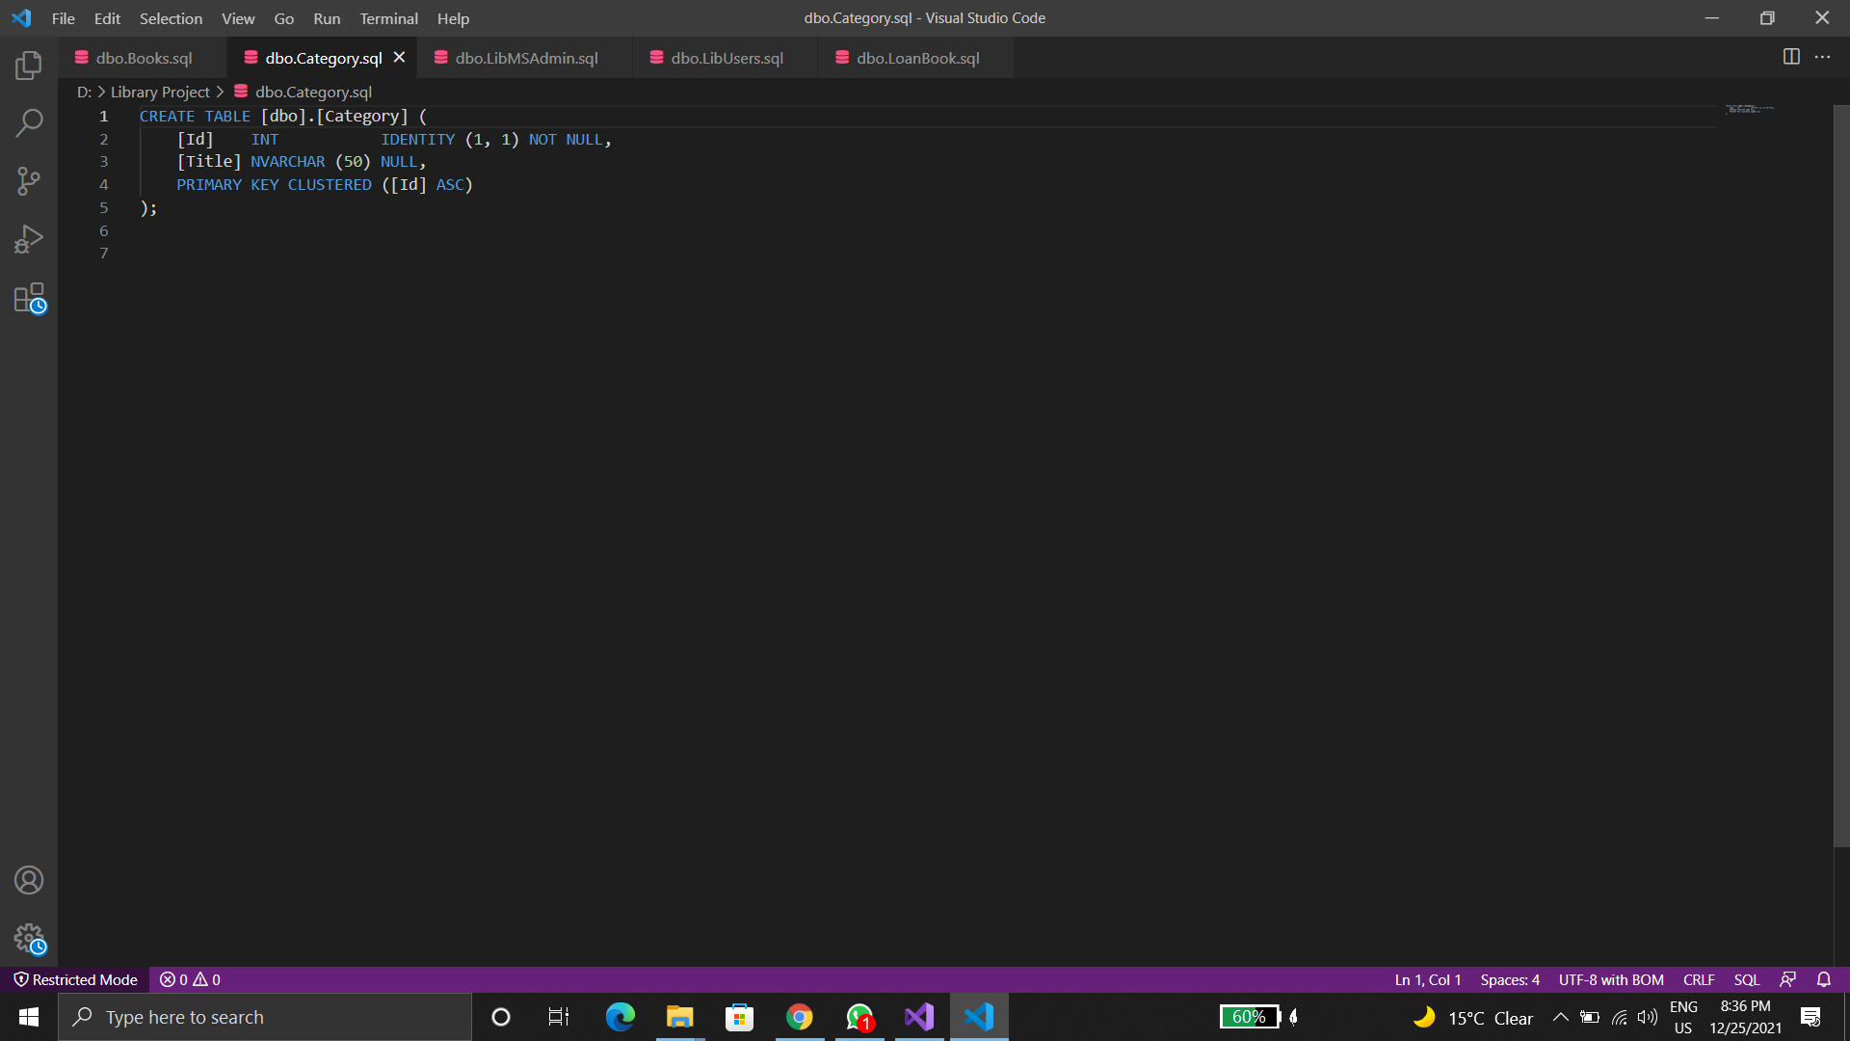

**LibAdmin:**

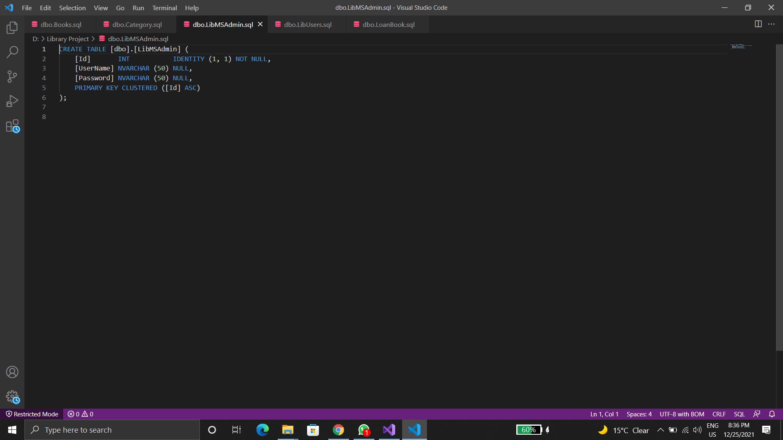

**LibUsers:** 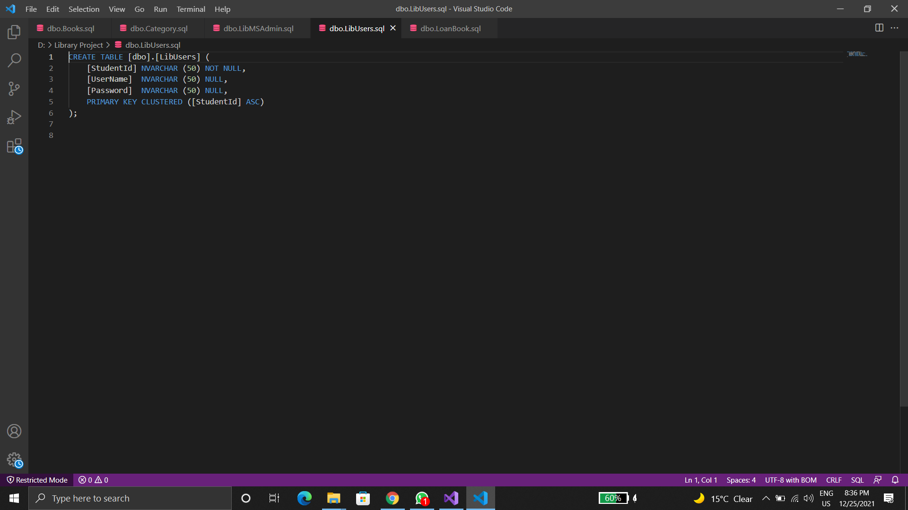

**Loan Book:**

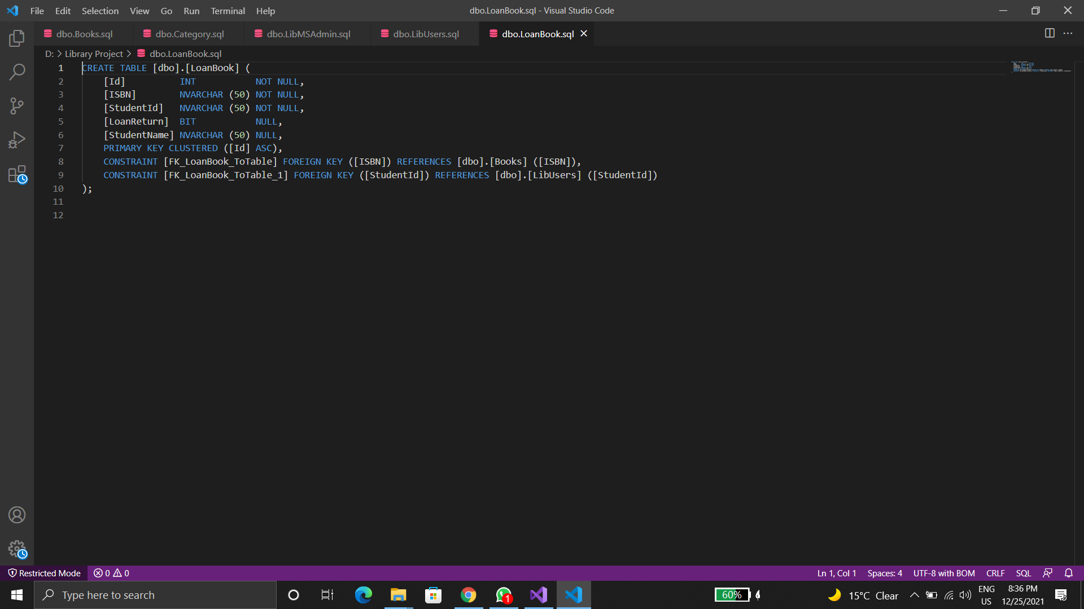

**5.Input/Output Interface Design:**

**1.Login**

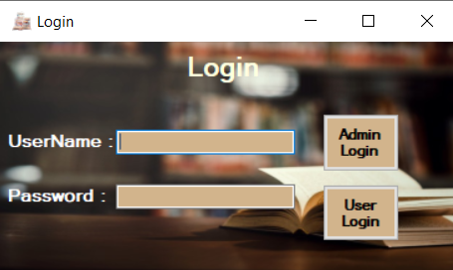

**2.Admin Actions**

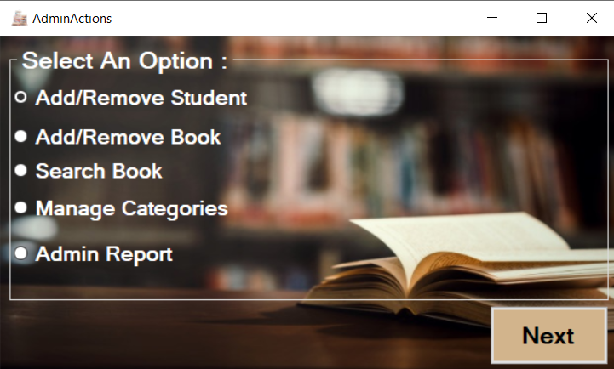

**Add/Remove Student**

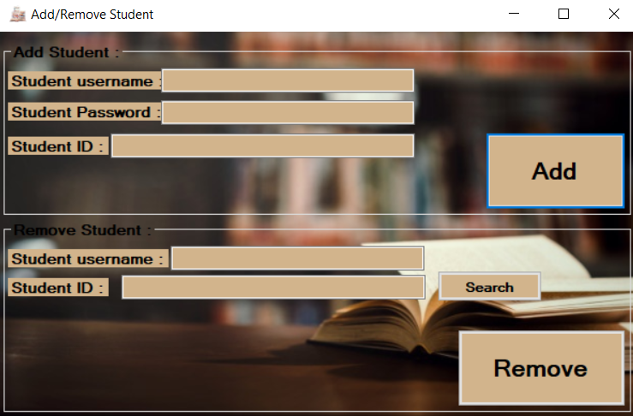

**Add/Remove Books**

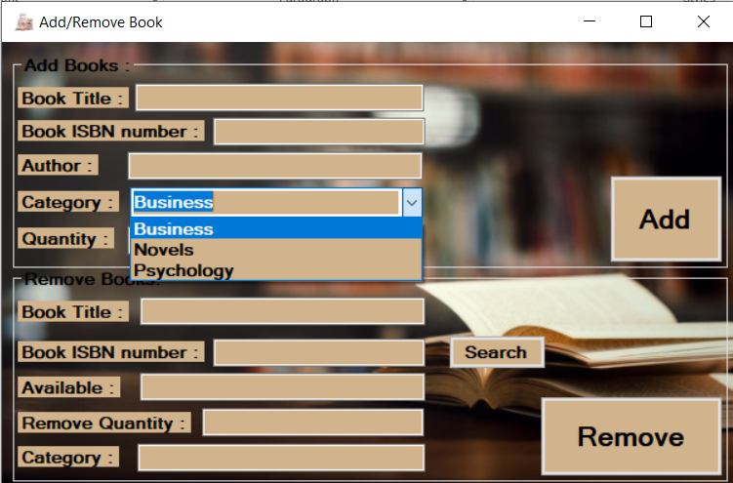

**Search a Book**

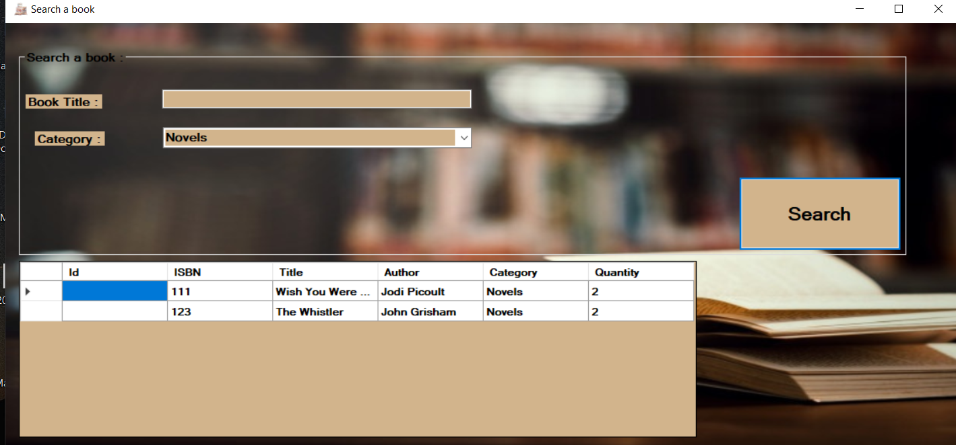

**Manage Categories**

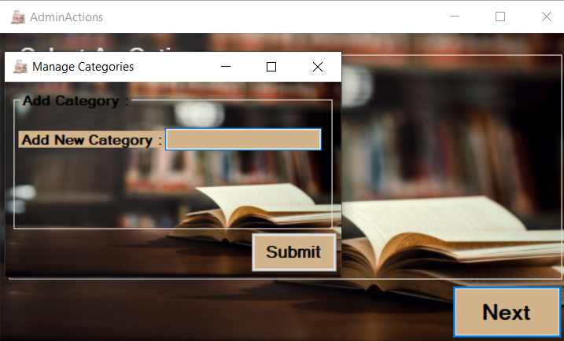

**Admin Report**

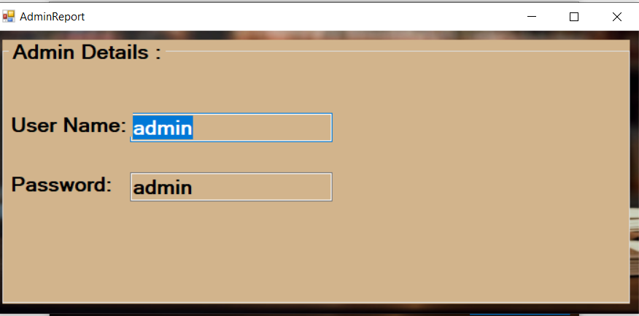

**3.User Actions**

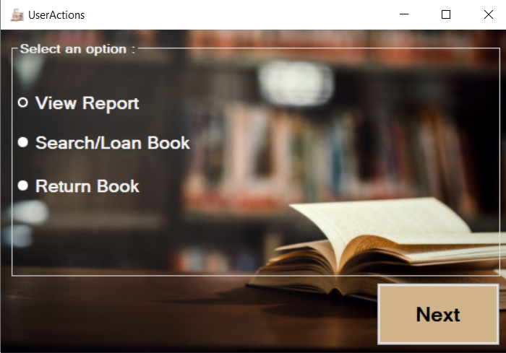

**View Report**

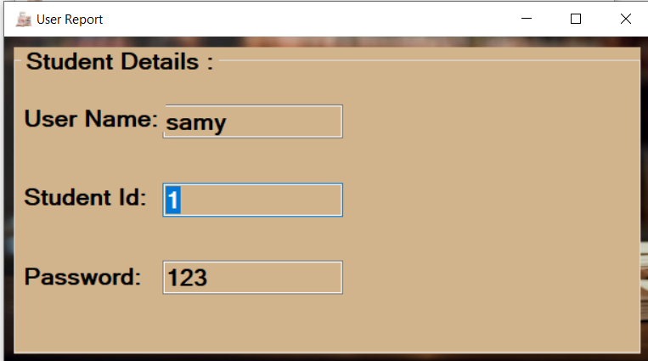

**Search/Loan Book**

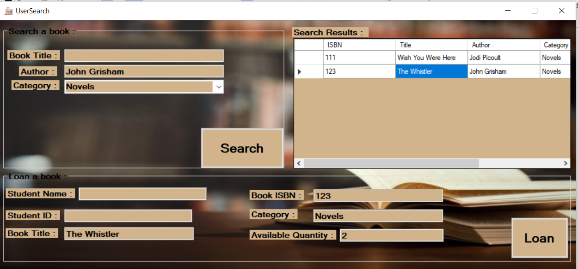

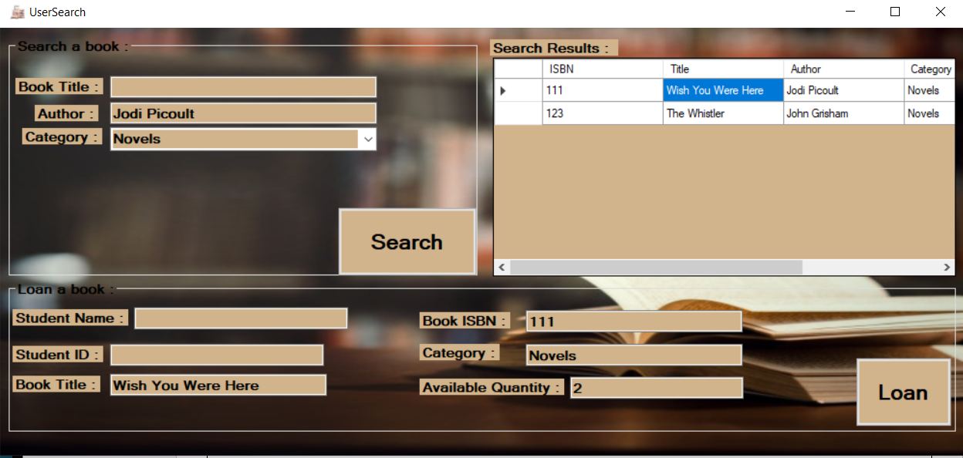

**Return a Book**

